**Research-centric Simulator for Swarm Robotic System**

**Activity Log**

Jeremy Lim Shih Wen

19064732

BSc (Hons) in Computer Science

Department of Computing and Information Systems

Sunway University Kuala Lumpur

Supervisor: Dr Richard Wong Teck Ken

July 20, 2023

Table of Contents

1 Timeline and Activities 3

1.1 Gantt Chart 3

1.1.1 Description of Tasks in Gantt Chart 4

2 Supervision Meeting Record 8

2.1 Week 2 8

2.2 Week 4 10

2.3 Week 6 12

2.4 Week 8 14

2.5 Week 10 16

2.6 Week 12 18

# Timeline and Activities

## Gantt Chart

A Gantt chart which consists of a list of tasks and the schedule to complete these tasks is designed as shown in Figure 1. The aim of the Gantt chart is to assist in the time management of the project and ensure the success of the project.

Figure 1 Gantt chart for capstone project.

### Description of Tasks in Gantt Chart

#### Capstone Project 1

1. Briefing on capstone project 1 (Week 1)

The first week consists of a briefing on the capstone project 1 which is provided by the course coordinator. One week allocated in this task is fixed because it depends on the course coordinator.

1. Decision on topic and supervisor (Week 2)

On the second week, the final year student must decide on a topic and a supervisor for the capstone project. One week allocated in this task is fixed because it depends on the course coordinator.

1. Preparation and finalization of Gantt chart (Week 3 – Week 4)

On the third and fourth week, the Gantt chart must be completed for planning purposes. Two weeks are allocated in this task because it is done simultaneously with task 4.

1. Preparation and finalization of introduction (Week 3 – Week 5)

On the third to fifth week, the introduction section of the report must be completed. Three weeks are allocated in this task because it is done simultaneously with task 3 and requires lots of research to a new topic.

1. Preparation and finalization of literature review (Week 6 – Week 9)

On the sixth to ninth week, the literature review section of the report must be completed. Four weeks are allocated in this task because it requires a lot of research to the new topic and a lot of time is required to gather, compile, and paraphrase the content.

1. Preparation and finalization of technical plan (Week 10 – Week 13)

On the tenth to thirteenth week, the technical plan section of the report must be completed. Four weeks are allocated in this task because it requires the application and deep understanding of content in literature review.

1. Review and finalization of planning document (Week 14)

On the last week, the planning document which consists of all the previous sections, are proofread, and reviewed. One week is allocated in this task because it only summarises up the planning document.

1. Completion of timeline, bibliography, meeting records (Week 2, Week 4, Week 6, Week 8, Week 10, Week 13)

The timeline and activities, bibliography and annotations, and meeting records are done throughout 14 weeks when meeting with the supervisor are held. Multiple weeks are allocated here because the meeting records need to be done bi-weekly.

1. Submission of planning document and activity log (Week 14)

The complete planning document and activity log are submitted for evaluation.

#### Capstone Project 2

1. Develop the basic graphical user interface of simulator (Week 1)

In week 1, the basic graphical user interface of the simulator is developed using *PyQt5* library. One week is allocated in this task because the development of the GUI can be based off the drafted wireframe.

1. Develop the simulator logic of simulator (Week 2 – Week 3)

In week 2 to 3, the simulator logic is implemented such as its base functionalities. Two weeks are allocated because the content of the simulator logic may take time to learn and apply.

1. Develop the swarm logic of simulator (Week 4 – Week 5)

In week 4 to 5, the swarm logic is developed such as the swarm models and algorithms. Two weeks are allocated because the content of the swarm logic may take time to learn and apply.

1. Integrate both swarm and simulator logic into the simulator (Week 6 – Week 8)

In week 6 to 8, both the swarm and simulator logic are integrated to develop a complete simulator. Three weeks are allocated because the integration of both parts can cause many bugs.

1. Test and debug the simulator functionalities according to test cases (Week 9)

In week 9, the complete simulator is tested according to the planned test cases and debugged where necessary. One week is allocated because the functionalities of the simulator are not too complex.

1. Prepare and finalize results and discussion (Week 10)

In week 10, the results and discussion sections of the report are written. One week is allocated because results and discussion can be written off the software testing section.

1. Proofread and revise the CP1 report and make changes (Week 10)

In week 10, the previous capstone project 1 report is revised and made changes where necessary. One week is allocated here together with task 6 because the report may require some changes.

1. Prepare and finalize conclusion (Week 11)

In week 11, the conclusion section of the report is prepared and finalized. One week is allocated here because conclusion will only require summarising the whole report.

1. Proofread and revise the CP2 report and make changes (Week 11)

In week 11, the complete capstone project 2 report is proofread and revised, and changes are made where necessary. One week allocated here together with task 8 because proofreading will not take too much time.

1. Submission of Final Report and Project Files (Week 12)

In week 12, the final report and project files of the capstone project are submitted for evaluation.

1. Prepare presentation slides (Week 12)

In week 12, the presentation slides are prepared for the upcoming presentation.

1. Presentation and Demonstration of Capstone Project (Week 12 – Week 14)

From week 12 to 14, a presentation slot is booked, and the capstone project is presented to the respective examiners.

# Supervision Meeting Record

## Week 2

**SCHOOL OF ENGINEERING AND TECHNOLOGY**

**DEPARTMENT OF COMPUTING AND INFORMATION SYSTEMS**

**SUPERVISION MEETING RECORD**

Date: 5 May 2023

Time: 2:00 p.m. – 2:30 p.m.

Student: Jeremy Lim Shih Wen

Supervisor: Dr Richard Wong Teck Ken

Updates from the previous meeting:

* N/A

Items discussed this meeting:

* Current progress on capstone project
* General plan on development of the capstone project
* Advise on current user interface of project
* Advise on planning document of project

Work for the coming meeting:

* Updated user interface of project
* Discussion on planning document
* Simulator logic of project

Supervisor’s Signature Student’s Signature



………………………………. ……………………………….

Relevant Notes:

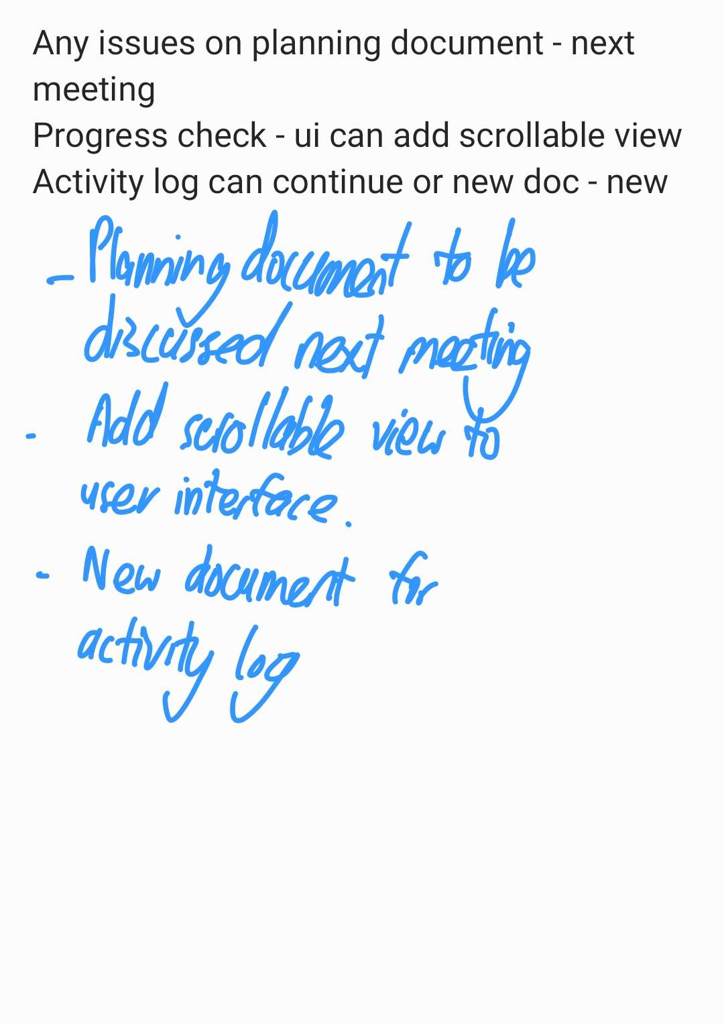

## Week 4

**SCHOOL OF ENGINEERING AND TECHNOLOGY**

**DEPARTMENT OF COMPUTING AND INFORMATION SYSTEMS**

**SUPERVISION MEETING RECORD**

Date: 15 May 2023

Time: 1:30 p.m. – 2:30 p.m.

Student: Jeremy Lim Shih Wen

Supervisor: Dr Richard Wong Teck Ken

Updates from the previous meeting:

Items discussed this meeting:

Work for the coming meeting:

Supervisor’s Signature Student’s Signature



………………………………. ……………………………….

Relevant Notes:

## Week 6

**SCHOOL OF ENGINEERING AND TECHNOLOGY**

**DEPARTMENT OF COMPUTING AND INFORMATION SYSTEMS**

**SUPERVISION MEETING RECORD**

Date: 29 May 2023

Time: 1:30 p.m. – 2:30 p.m.

Student: Jeremy Lim Shih Wen

Supervisor: Dr Richard Wong Teck Ken

Updates from the previous meeting:

Items discussed this meeting:

Work for the coming meeting:

Supervisor’s Signature Student’s Signature



………………………………. ……………………………….

Relevant Notes:

## Week 8

**SCHOOL OF ENGINEERING AND TECHNOLOGY**

**DEPARTMENT OF COMPUTING AND INFORMATION SYSTEMS**

**SUPERVISION MEETING RECORD**

Date: 19 June 2023

Time: 1:30 p.m. – 2:30 p.m.

Student: Jeremy Lim Shih Wen

Supervisor: Dr Richard Wong Teck Ken

Updates from the previous meeting:

Items discussed this meeting:

Work for the coming meeting:

Supervisor’s Signature Student’s Signature



………………………………. ……………………………….

Relevant Notes:

## Week 10

**SCHOOL OF ENGINEERING AND TECHNOLOGY**

**DEPARTMENT OF COMPUTING AND INFORMATION SYSTEMS**

**SUPERVISION MEETING RECORD**

Date: 3 July 2023

Time: 1:30 p.m. – 2:30 p.m.

Student: Jeremy Lim Shih Wen

Supervisor: Dr Richard Wong Teck Ken

Updates from the previous meeting:

Items discussed this meeting:

Work for the coming meeting:

Supervisor’s Signature Student’s Signature



………………………………. ……………………………….

Relevant Notes:

## Week 12

**SCHOOL OF ENGINEERING AND TECHNOLOGY**

**DEPARTMENT OF COMPUTING AND INFORMATION SYSTEMS**

**SUPERVISION MEETING RECORD**

Date: 17 July 2023

Time: 1:30 p.m. – 2:30 p.m.

Student: Jeremy Lim Shih Wen

Supervisor: Dr Richard Wong Teck Ken

Updates from the previous meeting:

Items discussed this meeting:

Work for the coming meeting:

Supervisor’s Signature Student’s Signature



………………………………. ……………………………….

Relevant Notes: